PRESS RELEASE

The Honotel Group partners with Bpifrance and BNP Paribas Développement to launch “GLINT, Hostel & Suites”, its new hybrid hotel brand.
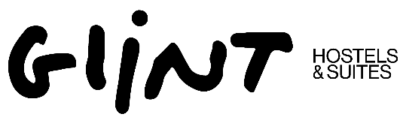

Paris, October 28, 2025 – The Honotel Group, a leading player in hotel investment and management, announces the launch of its new brand, GLINT, Hostel & Suites, with the support of Bpifrance (through its France Investissement Tourisme 3 fund) and BNP Paribas Développement. With an initial base of six secured properties in key French cities, GLINT aims to become a leading player in the hostel market, with plans to develop around twenty establishments across France and Europe by 2030.

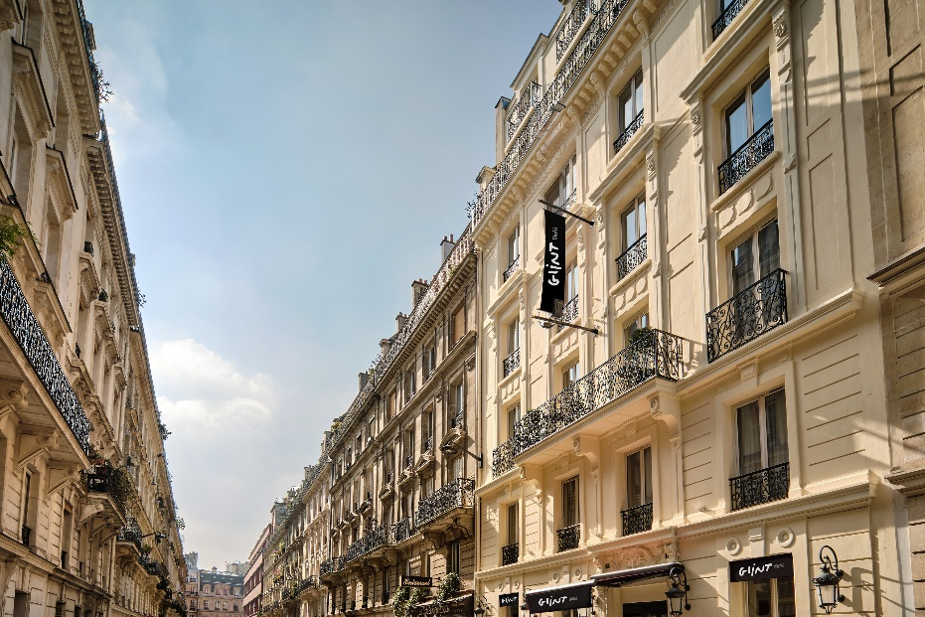 | 

Thanks to its innovative approach, Honotel reaffirms its desire to redefine hospitality standards with the creation of its “GLINT, Hostel & Suites” brand, which offers timeless, welcoming, andaffordable accommodation located in the heart of cities. The establishments will feature flexible rooms and bed rates, combining the conviviality of a hostel with the comfort of a boutique hotel.

The partnership between Honotel, HIC (a management company and subsidiary of the Honotel group), Bpifrance (through its France Investissement Tourisme 3 fund) and BNP Paribas Développement, marks a first strategic step in the brand’s launch, with the acquisition of six initial establishments (400 rooms offering 1,500 beds) ideally located in the heart of Paris, Lyon, Nice, Bordeaux, Strasbourg, and Toulouse. These will open under the “GLINT, Hostel & Suites” brand in 2026 and 2027.

With multiple development opportunities under consideration, the brand intends to pursue its expansion in key French and European cities, backed by its existing investors and potential new partners.

Laurent Lapouille, President of Honotel : “GLINT, Hostel & Suites represents a solid investment opportunity thanks to its ability to deliver significantly higher economic performance than traditional hotels in the same locations. Moreover, the concept’shigh flexibility enables both existing hotels and office buildings to be converted into GLINT properties, multiplying developmentopportunities.”

Flavien Tiberghien and Manoel Assaf, from Bpifrance : "We are proud to be partner with the Honotel Group for the launch of GLINT, Hostel & Suites. This new hybrid hospitality brand perfectly reflects the innovation and adaptability required in today's tourism sector. We look forward to contributing to its ambitious growth and helping to redefine hospitality standards in France and across Europe."

Philippe Duny and Baptiste Alain from BNP Paribas Développement : "With the GLINT project, Honotel demonstrates the French hotel industry's capacity to develop concepts aligned with evolving travel habits and the democratization of tourism. The creation of this first platform brings together industry specialists we are proud to partner with the ambition of esablishing a leading hospitality brand in Europe."

Parties involved in the transaction:

Honotel Group : Laurent Lapouille, Hélène Gauthier, Patrick Luis
HI-Capital : Julien Montillo, William Méon
Bpifrance Investissement : Flavien Tiberghien, Manoel Assaf, Fabrice Cacoub
BNP Developpement : Philippe Duny, Baptiste Alain, Walid Chekroud

Press contacts:

Honotel
Agence Wellcom
Sarah Nascimento & Inès Eymerie
honotel@wellcom.fr

Bpifrance
Juliette Fontanillas
Phone : + 33 6 72 76 08 09
juliette.fontanillas@bpifrance.fr

About Honotel

Honotel is an independent company specializing in hotel investment and management, with more than 100 private equity hotel transactions completed since its creation. Co-directed by Laurent Lapouille, Hélène
Gauthier, and Patrick Luis, Honotel stands out for the longstanding commitment of its founders and managing partners, all of whom come from the hospitality industry.
Renowned for its expertise, the Group has earned the trust of major investors,, whom it supports over the long term through a comprehensive high value_added offering built around three core areas of expertise :: Hotel investment (conducted through club deals, lease management or via its portfolio management company, Hôtel Investissement Capital) – Operational management (provided in-house, under management mandate, or under a white label approach) – Operations monitoring (supporting institutional investors in maximizing value creation).
For more information: www.honotel.com

About Bpifrance

Bpifrance's equity investments are managed by Bpifrance Investissement. Bpifrance finances companies at every stage of their development through loans, guarantees, and equity investments. Bpifrance also supports them in their innovation and international projects. In addition, Bpifrance insures their export activities through a comprehensive range of products. Its offer also includes consulting, training, networking, and acceleration programs tailored to startups, SMEs, and mid-cap companies.
Thanks to its 50 regional offices, Bpifrance provides entrepreneurs with a local, single point of contact, offering effective support to help them meet their growth and transformation challenges.

For more information : www.Bpifrance.fr - https://presse.bpifrance.fr/
Folow us on Twitter : @Bpifrance - @BpifrancePresse

About BNP Developpement

BNP Paribas Développement, a subsidiary of the international banking group BNP Paribas, is a public limited company that has been directly investing its own funds as a minority shareholder for over 37 years. Its mission is to support the growth of high-performing SMEs and mid-cap companies and to ensure their long-term sustainability by facilitating business transfers.
Beyond providing the company with the financial resources needed to secure stable funding, BNP Paribas Développement's is committed to supporting management teams over the long term in the implementation of its medium-term strategic projects. Its minority shareholder position guarantees its partners appropriate governance without interfering in day-to-day operations, while offering the strength of a recognized banking group and the expertise of a partner managing a portfolio of more than 600 diversified investments.
For more information: https://www.bnpparibasdeveloppement.com/
And about our investments: https://www.linkedin.com/company/bnp-paribas-développement

